Building an Agentic Stock Screening System: Where AI Meets Wall Street
How our team combined Agentic AI/machine learning with financial analysis to predict S&P 500 stock performance
This article was produced as part of the final project for Harvard’s AC215 Fall 2025 course.
Links: Project Github Repo, Video
Team: Stock Buster — Sirisom Pranivong, Majid Uppal, Seraphim Eilken ,Mahmood Masqati

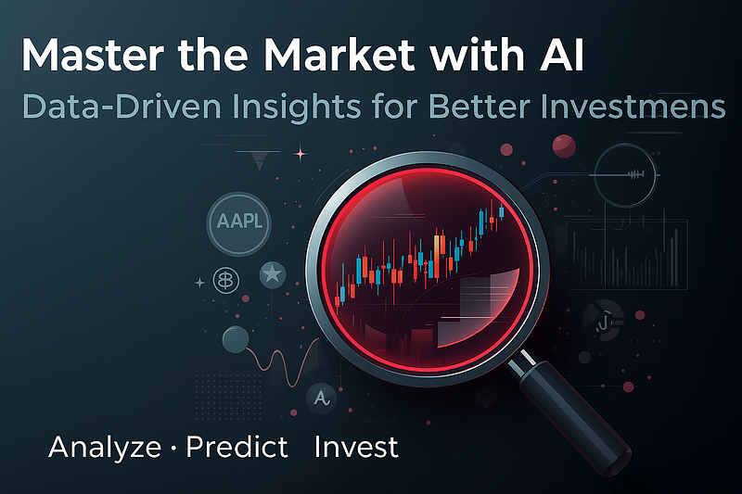

Table of Contents
- The Challenges
- Our Solution: A 7-Step Quantamental Model ML Pipeline
- RAG-Powered Investment Reasoning
- API & Frontend
- Cloud Deployment & Scaling
- CI/CD Pipeline
- Results
- Known Limitations & Future Opportunities
- References

1. The Challenges (Siri)
Every day, millions of investors face the same question: which stocks will outperform the market? Traditional approaches fall into two camps — quantitative analysis (using mathematical models and technical indicators) and fundamental analysis (evaluating company financials and business health). Wall Street has long debated which approach works better.
But there’s another challenge: everyday investors are trapped in the noise. Information overload from news, charts, and reports leads to analysis paralysis. Emotional decision-making driven by fear and greed sabotages investment strategies. Most retail investors — especially beginners with limited experience — end up underperforming benchmark indexes simply because they lack the tools that professionals have.
Our team asked: What if we could combine both analytical approaches AND make it accessible to everyone?
This “quantamental” approach — blending quantitative signals with fundamental data — forms the foundation of our automated stock analysis system. Built as part of Harvard’s AC215 course, our platform empowers novice investors, busy professionals, and DIY retirement savers by analyzing over 400 S&P 500 stocks daily. Instead of overwhelming users with raw data, we provide clear Buy/Hold/Avoid signals with AI-powered explanations that anyone can understand — no finance degree required.

2. Our Solution: A 7-Step Quantamental Model ML Pipeline (Siri)

3. RAG-Powered Investment Reasoning (Seraphim) Noah Eilken

4. API & Frontend (Mahmood & Majid)

5. Cloud Deployment & Scaling (Mahmood and Majid)
6. CI/CD Pipeline (Seraphim)

7. Results (?? Front end snapshot ? )

8. Known Limitations & Future Opportunities (Everyone)

9.References (Everyone)

